HARDWARE REQUIREMENTS:
- ESP32 – CAM Module
- USB-To-TTL Converter
- Push Buttons
- LEDs
- Bread Board
- Jumper Wires
SOFTWARE REQUIREMENTS:
- Espressif Flash Download Tool
- Putty
WIRING ASSEMBLY:
Firstly, connect the Camera Sensor with the FPC connector of ESP32-CAM, as shown:
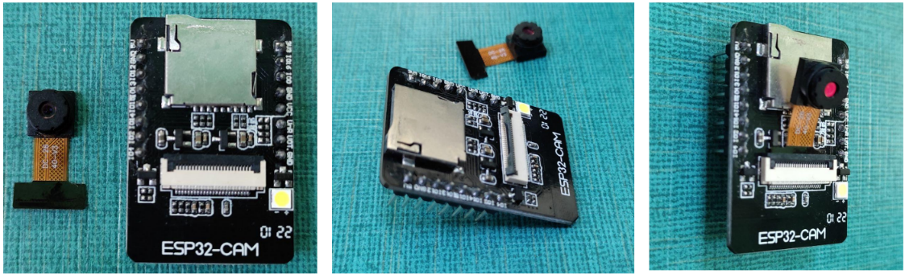
Connect ESP32 - CAM with USB-to-TTL converter by using female-to-female jumper wires, as shown:
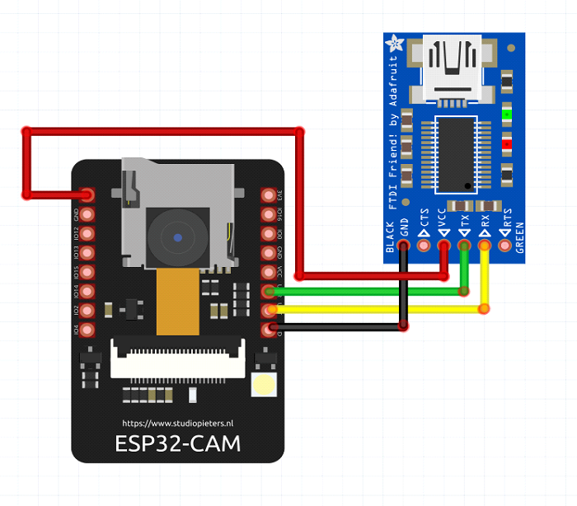
Connect Leds and Push Buttons with the above circuit, by using breadboard and jumper-wires.
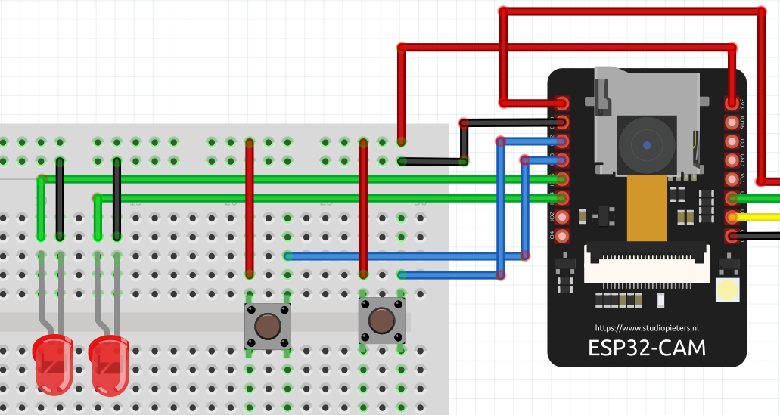
FIRMWARE UPLOAD & TESTING:
First you have to connect the GPIO0 to GND and press the reset button of the ESP32-Cam board for “FLASH MODE”.
Insert the USB-To-TTL Converter into the PC USB-Port.
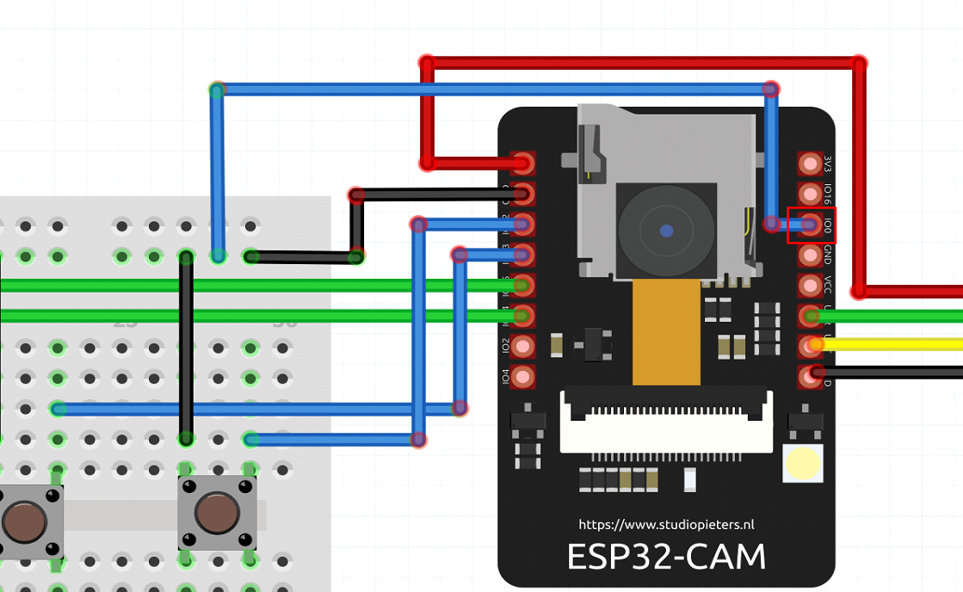
Open the Device Manager->Ports to check the COM Port.
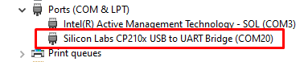
Now, open the “Flash Download Tool” and select “ESP32” as ChipType & press OK.
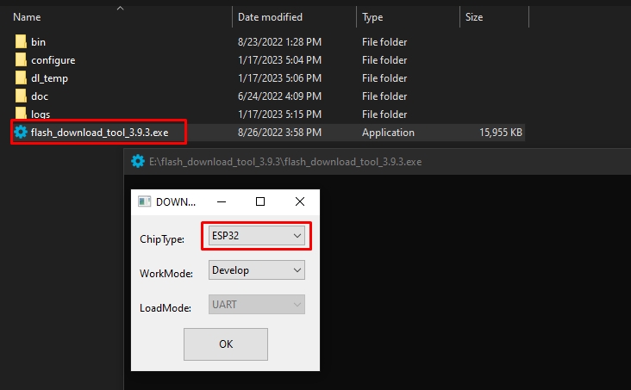
Now, Select the following configuration and the click on the “...” icon to select the bin files from the directories:
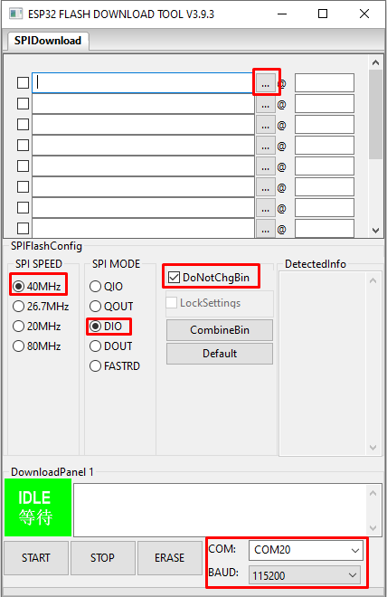
Select the “bin files” in the following order and insert the “values” as shown below.
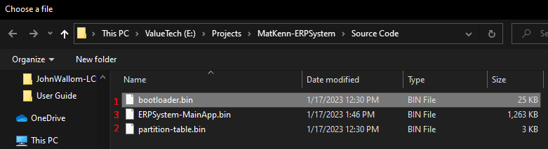
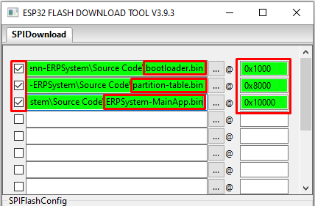
Click on the “Start” button & the firmware begins uploading.
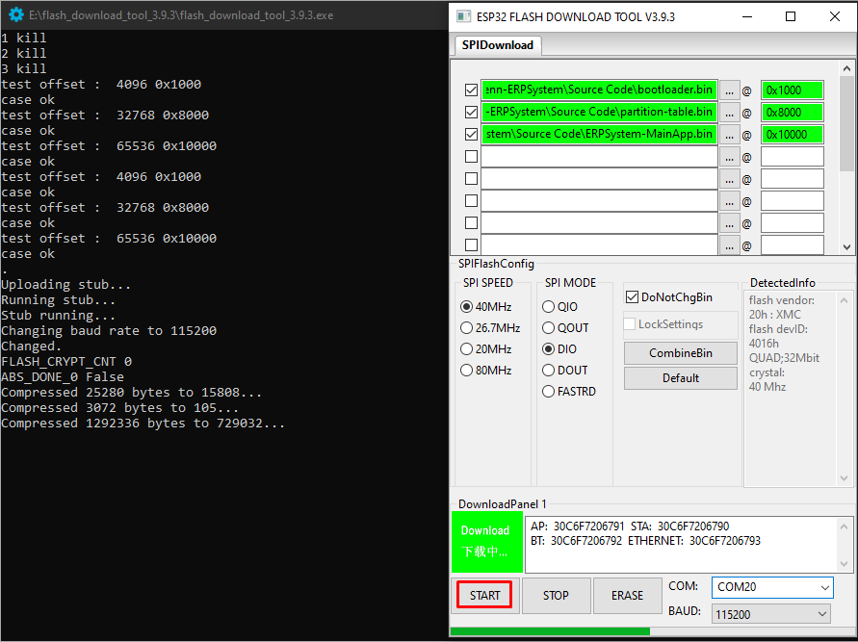
The following message shows that the firmware upload successfully!
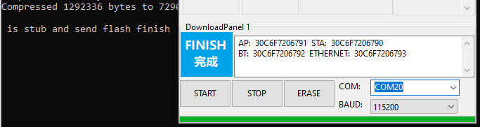
Disconnect the GPIO0 from GND and press the reset button, to select the “RUN MODE”.
Open Putty for the output logs, as shown:
(Press the Reset Button if the Output Terminal is blank)
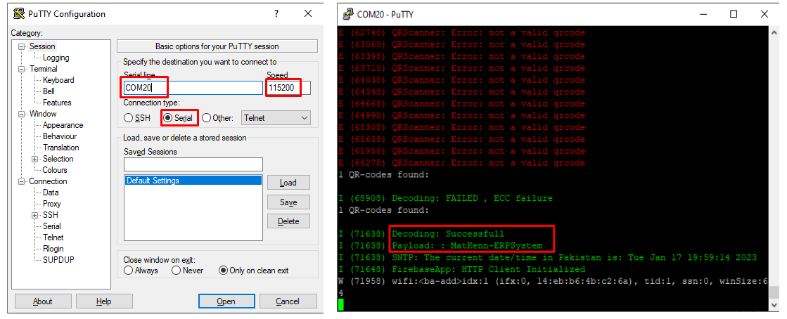
Open the official Firebase website and click on “Get Started”.
Sign-in with the provided credentials and click on “MatKenn-ERPSystem”.
Go to Realtime Database->Data, and here you can access the QR Scanner data.
